The Australian - September 25, 2017

Rock art researcher Grahame Walsh got it wrong
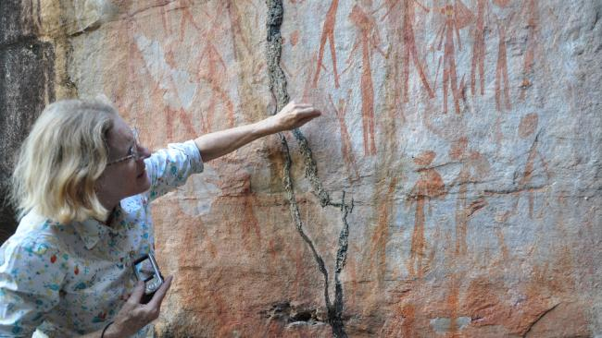Maria Myers with Bradshaw (Gwion Gwion) rock art. Picture: Kimberley Foundation Australia
One of Australia’s most controversial rock art researchers, Grahame Walsh, was wrong when he insisted that the extraordinary epochs of Kimberley rock art were unconnected and probably made by long-since disappeared Aboriginal peoples.
Yet the late Walsh’s meticulous recording of the Kimberley’s most remote art-decorated caves went on to become the bedrock of current research that appears to disprove his own theory of discontinuity.
Kimberley Foundation Australia chair Maria Myers, who knew Walsh well until his death in 2007, says a decade of scientific study of rock art based on Walsh’s legacy is revealing a different picture of prehistoric artistry in the Kimberley.
Walsh believed that no continuous link existed between the painting of the Gwion or Bradshaw period, which featured what he called the ‘clothes peg’ figures, and the beginning of the Wandjina period of wide-eyed spirit figures. They appeared to be made by different tribes, he concluded.
But in the ten years since Walsh died, “we have found more and more sites that we don’t know whether to put in the clothes peg period or the early Wandjina period,” says Myers.
“They are what Grahame always said he couldn’t find — they are transitional. So there is no period of discontinuity between the two.”
It suggests that traditional owners living and working today alongside rock art specialists have a cultural connection dating back at least 20,000 years to the Kimberley’s prehistoric artists.
Myers says Walsh’s passion for mapping sites has been crucial in current efforts to date the art and describe the role of migration across Northern Australia in creating discrete art phases — twin research conducted by the University of Western Australia’s Kimberley Visions project and pioneering dating techniques led by the University of Melbourne.
“We couldn’t be doing this work without Grahame’s archive,” says Myers. “We can find the sites from his recordings and take everybody there.”
This year, around 40 scientists from multiple universities including researchers from France, Mexico and Chile have been working on the mysteries of Kimberley rock art.
Myers says Walsh was a difficult man, alternately generous and bullying and always fiercely protective of his maps of thousands of sites.
But in a speech in Perth tomorrow night to mark 20 years of the Kimberley Foundation, Myer will reveal new aspects of the man accused of withholding sensitive information from indigenous custodians.
Myers was bestowed Walsh’s archive by his family two years after his death from a brain tumour in 2007.
She says his handwritten field notes contain moving evidence of Walsh’s deep respect for Kimberley Balanggarra lawmen like Sam Woolagoodja.
“Every year he was with Aboriginal people on site, and he had a longstanding relationship with Sam and would meet with him on every Kimberley trip.
Walsh wrote: “During the numerous times working with Woolagoodja, he touched upon a wide range of subjects. Some of these were essential in my developing an understanding of traditional values associated with rock art.”
In the mid-1970s, another man Mimi (Roly) Tjeeryin took Walsh to the most important Wandjina rock galleries. Walsh wrote that the man “formally introduced” him to the Wandjinas in the traditional way, “patiently reliving the mythology until he was satisfied I had it in every detail.”
Myers says the belief system of the Wandjina people became one that Walsh most believed in himself. “He was in awe of it.”
She says when a dying Walsh — aged 62 — was hospitalised in 2007, he was asked to nominate his religion.
“He said straight off ‘I’m Wandjina, that’s my belief system.’”
“But it was truth he was after, he wanted to understand the huge changes in rock art style. And he could see that it was Australia’s story that was tied up in the explanation.”
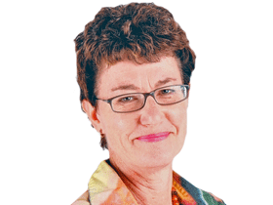
Senior reporter - Perth

